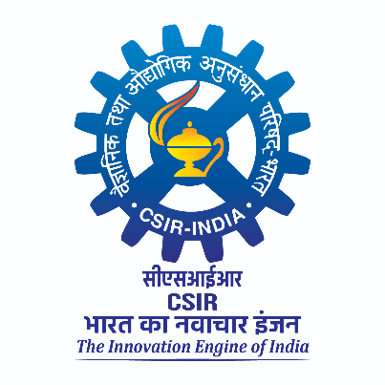
CECRI- Madras Unit, CSIR Madras Complex, Chennai-600 113

Date: 04-03-2026

Subject: Gate entry for Battery division

Scientist to be visited:

Date of visit:

Visitor name:

Visitor affiliation:

Purpose:

I kindly request the SIC to permit entry into our premises.

Scientist-in-Charge Dr. A S Prakash
Chief Scientist

